



Implementation of Python Function Arguments with different types
LAB MANUAL

Disclaimer: The content is curated from online/offline resources and used for educational purpose only
Implementation of Python Function Arguments with different types
Objective:
- Learn how to define functions that accept different types of arguments (positional, keyword, default, variable-length).
- Gain experience in handling various data types (integers, strings, lists, dictionaries) as function arguments.
- Understand how to create flexible functions that can accept different types of inputs and adapt their behavior accordingly.
- Apply the knowledge to write functions that can perform various operations based on the input arguments.
Problem Statement:
Create a Python program that defines multiple functions demonstrating the use of different types of function arguments. The program should include:
- A function with positional arguments that calculates the area of a rectangle.
- A function with default arguments that greets a user with a default name if none is provided.
- A function with keyword arguments that constructs a descriptive message about a person based on their name and age.
- A function with variable-length arguments that computes the sum of an arbitrary number of numbers.
Equipment Required:
- Install VS Code - https://code.visualstudio.com/download
- Download Python Installer File - https://www.python.org/downloads/
Prerequisites:
- Basic Computer Skills - Anyone starting to learn computer programming needs basic computer skills.
- Basics of control statements

Procedure:
Task 1: Implementation of Positional Arguments
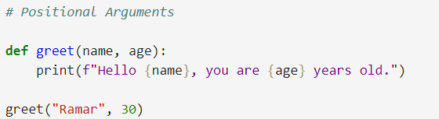
Output:
name and age are positional arguments, which means the order of the arguments matters when calling the function.
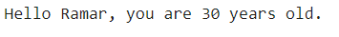
This demonstrates that positional arguments depend on the order in which they are provided.

Task 2: Implementation of Keyword Arguments
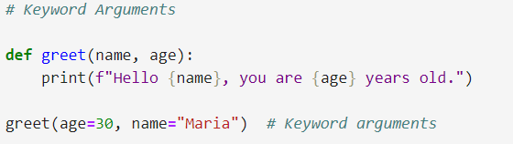
Output:
Using keyword arguments makes the code more readable and clear. It is immediately obvious which value corresponds to which parameter.
Task 3: Implementation of Default Arguments
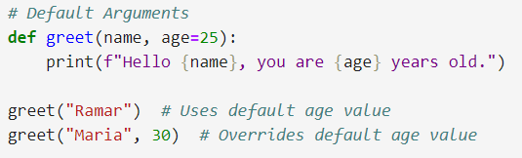
Output :
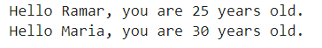
Default arguments allow you to create functions that can be called with fewer arguments, making them more versatile.
Task 4: Implementation of Variable-Length Arguments
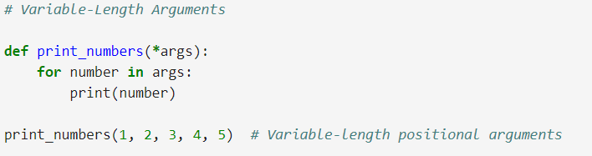
Output:
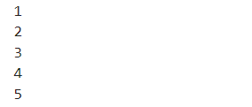
The function print_numbers is defined with a parameter *args. The * before args allows the function to accept any number of positional arguments, which will be treated as a tuple. Inside the function, a for loop iterates over the args tuple and prints each number.
Task 5: Implementation of Keyword Variable-Length Arguments (**kwargs)
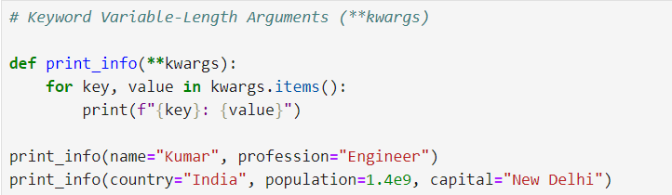
Output:
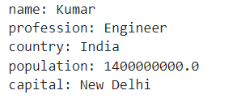
Using keyword variable-length arguments with **kwargs in Python provides significant flexibility in function definitions. This allows you to create functions that can handle a varying number of named inputs easily, which is especially useful in many programming scenarios such as configuration settings or dynamic attribute handling.

Task 6: Implementation of Mixing Different Argument Types
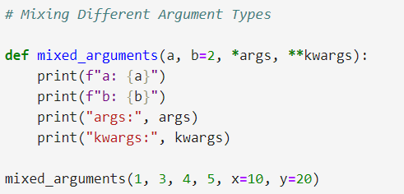
Output:

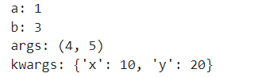
Mixing different types of arguments in Python functions provides significant flexibility and power. This allows you to create functions that can handle a variety of input scenarios, making your code more dynamic and easier to manage.

